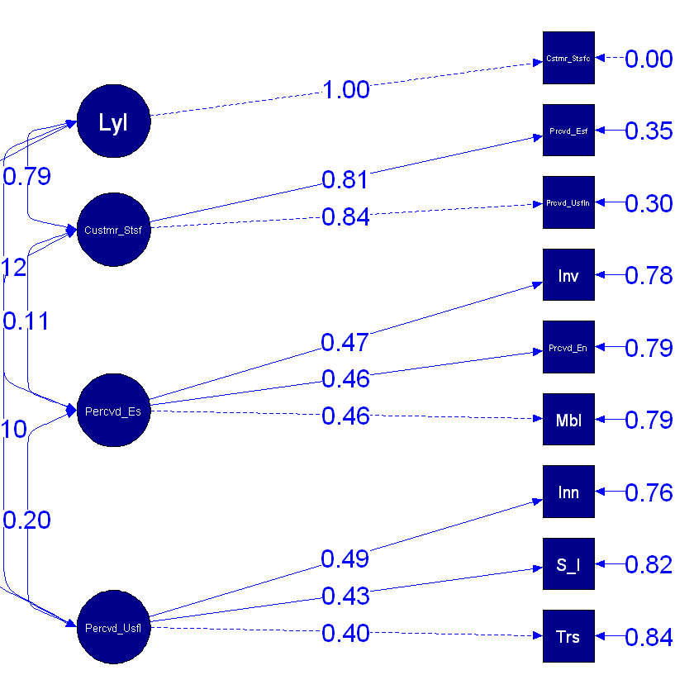

Here is an explanation of the findings in the context of a customer satisfaction research based on the fit indices that were supplied for your SEM model:

**Fit Indices:**

**1.Chi-Square (χ²): 25.739**

Degrees of Freedom (df): 22

p-value: 0.263

The difference between the observed and expected covariance matrices is evaluated using the chi-square test. A good fit is shown by a non-significant p-value (higher than 0.05), which shows that there is no significant discrepancy between the model and the observed data.   
The p-value in this case is 0.263, meaning it is not significant. Considering that the difference is not statistically significant, this indicates that the model fits the data well enough.

**2. Comparative Fit Index (CFI): 0.996**

The CFI assesses how well your model fits against a baseline model, or null model, which assumes no correlations between any variables. CFI value range

A CFI of 0.996 suggests an excellent model fit.

**3. Tucker-Lewis Index (TLI): 0.993**

The TLI accounts for model complexity, exactly like the CFI does. A better fit is indicated by a value nearer 1. Values over 0.90 are usually regarded as satisfactory, and values over 0.95 as exceptional.   
Your model fits the data quite well, as evidenced by its TLI of 0.993, which suggests that the extra complexity you included in the model is appropriate.

**4. Root Mean Square Error of Approximation (RMSEA): 0.017**

The difference between the estimated and observed covariance matrices per degree of freedom is measured by RMSEA. A close fit is shown by values less than 0.05, and a fair fit is indicated by values between 0.05 and 0.08.   
An excellent match is indicated by an RMSEA of 0.017, which indicates that the model closely resembles the observed data.

**5. Standardized Root Mean Square Residual (SRMR): 0.033**

The standardized difference between observed and expected correlations is known as the SRMR. Excellent fit is indicated by values smaller than 0.08.   
A very excellent match is shown by an SRMR of 0.033, which also suggests that the residuals—differences between observed and predicted values are small

**Interpretation in the Context of Customer Satisfaction:**

The model shows a very good to exceptional fit to the observed data based on the fit indices. This indicates that the underlying structure of customer satisfaction in the particular context is successfully captured by the links that are specified between latent constructs and observable variables. In particular:   
1. Social influence, innovativeness, and trust all contribute to the explanation of perceived usefulness.   
2. Mobility, Perceived Enjoyment, and Involvement provide a good explanation for perceived ease of use.   
3. Both perceived usefulness and perceived ease of use have a major impact on customer satisfaction.   
4. One important result of customer satisfaction is loyalty.

**Real-World Marketing Implications:**

1. Trust, Social Influence, and Innovativeness are critical components of perceived usefulness. Marketing campaigns or product strategies should therefore emphasize building trust and showcasing innovative features.

2. Enhancing Mobility and Enjoyment while providing engaging customer Involvement opportunities can significantly impact perceived ease of use.

3. The strong relationship between Customer Satisfaction and Loyalty suggests that companies should invest in improving customer satisfaction to foster long-term loyalty.

These insights can be used by marketers to design customer satisfaction improvement programs, develop targeted marketing strategies, and create interventions that focus on the areas with the most significant impact on loyalty and overall satisfaction.